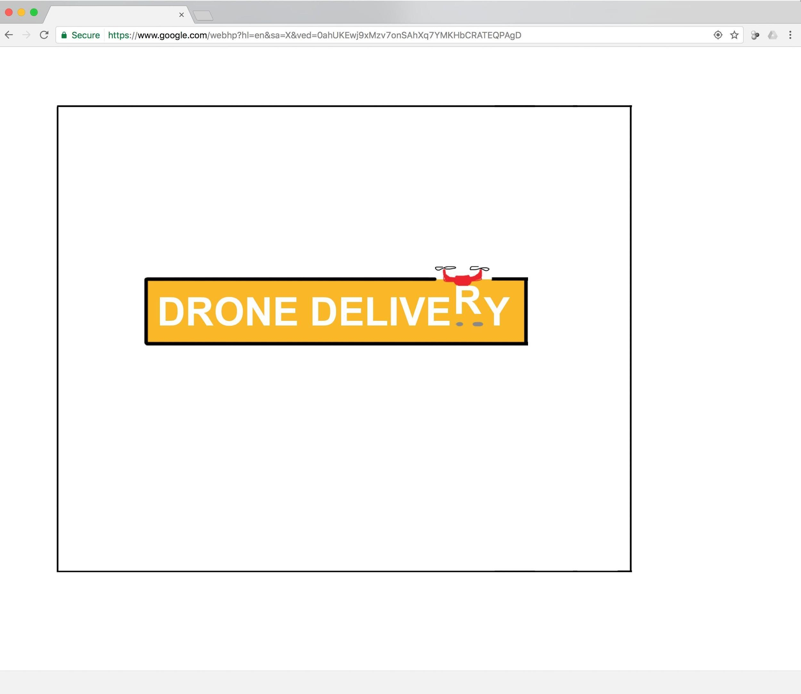

**Drone Delivery Progress Update:**

We’ve created a course that will test all of the features we’ve developed thus far:

* We have designed the Drone, The Package, the Container the drone is placed inside, the Ocean, the Drop Zone, and Walls.
* We have completed collision detection and movement for Drone / container and for The Package when it is independent moving in space.
* We’ve added an enemy (the Ocean), platforms, and walls to test hazard detection and movement abilities.
* We’ve animated the drone propellers and ocean.
* We’ve added the Drop Zone to test game end events.
* The game can be paused.
* We have basic GUI functionality, like a title, text when the game is paused, and alerts when game events occur. We will build on these in future phases.

**Credits / Backlog**

D: Drone P: Package O: Objects PP: Power pack GUI: GUI G: Gameplay C: Code

| **Item** | **Phase** | **Type** | **Responsible** | **Done?** |
| --- | --- | --- | --- | --- |
| **Design course with wall, drop zone, ocean, platforms, The Package, and Drone, drop zone, hazard events functional, collision detection, movement controls functional for both package and Drone, ability to pause the game, add Container design** | **1** | **-** | **together** | **X** |
| Add ability for drone to pick up objects | 1 | D | Ryan | X |
| Add Collision Detection (drone) with game objects, game frame | 1 | D | Ryan | X |
| Add Drone movement controls | 1 | D | Ryan | X |
| Add interaction b/w drone and hazards | 1 | D | Jack | X |
| Add interaction b/w package and hazards | 1 | D | Jack | X |
| Animate Drone propellers | 1 | D | Ryan | X |
| Design Drone, add to game | 1 | D | Ryan | X |
| Add drop zone event | 1 | G | Jack | X |
| Add pause text | 1 | GUI | Jack | X |
| Add end-course event (Drone or Package hit hazard) | 1 | G | Jack | X |
| Add pause functionality | 1 | G | Ryan | X |
| Add background as bitmap | 1 | O | Ryan | X |
| Design container, add to game | 1 | O | Ryan | X |
| Design Drop Zone, add to game | 1 | O | Jack | X |
| Design Game background | 1 | O | Ryan | X |
| Design Ocean, add to game | 1 | O | Ryan | X |
| Design Wall and floor, add to game | 1 | O | Ryan | X |
| Add Collision Detection (Package) | 1 | P | Ryan | X |
| Add Package movement ability (independent of drone / dependent on drone) | 1 | P | Ryan | X |
| Design The Package, add to game | 1 | P | Ryan | X |
| Determine mechanics for how package relates to drone (move with drone, move independent of drone and can be dislodged) | 1 | P | Together | X |
| Animate Ocean (water movement / waves) | 1 | O | Ryan | X |
| **Design course with Flock-of-Birds, animate Flock-of-Birds movement, include ability to start new game from paused situation or after losing the course, add a game timer, improve JS functions** | **2** | **-** | **together** |  |
| Add “new game” space bar functionality to pause screen | 2 | G | Jack |  |
| Design Flock-of-Birds, add to game | 1 | O | Jack |  |
| Revise in-game pause menu / text | 2 | GUI | Jack |  |
| Add game timer functionality | 2 | G | Ryan |  |
| Add game timer visualization | 2 | GUI | Ryan |  |
| Animate Flock-Of-Birds (fly side to side) | 2 | O | Jack |  |
| Implement generic wall creation method | 2 | O | Ryan |  |
| Add end-course event (timer runs out) | 2 | G | Ryan |  |
| **Design course with sprites, end-course events of running out of time, improve the GUI for the user** | **3** | **-** | **together** |  |
| Add Game Start Screen | 3 | GUI | Ryan |  |
| Improve Drone propeller design and animation | 3 | D | Ryan |  |
| Add end-course/ end-game notification popup in-screen, pauses game after winning or being destroyed | 3 | GUI | Jack |  |
| Add level number visualization | 3 | GUI | Jack |  |
| Add paused game text at beginning of each course | 3 | GUI | Jack |  |
| Add explanation of gameplay / goal at beginning of game | 4 | GUI | Ryan |  |
| Design Sprites, add to game | 3 | O | Jack |  |
| **Add course where all animations are implemented, start screen added, explanation of gameplay, course 1 is fully designed (all game objects in place)** | **4** | **-** | **together** |  |
| Improve differentiation of movement of drone and package, such as:   * drone moves faster when flying upward * package retains same horizontal speed when dropped from drone * drone moves slower when carrying the package than otherwise | 4 | D | Ryan |  |
| Diagram the functions and relationships of the code | 4 | C | Ryan |  |
| Add comments and description to code | 4 | C | Ryan |  |
| Add comments to code | 4 | C | Jack |  |
| Add Sprite animation to game | 4 | O | Jack |  |
| Design Sprite animation | 4 | O | Jack |  |
| **Present finished Course 1 with all features** | **5** | **-** | **Together** |  |